# [Voyage] Site Plan

## [Kaden Watts]

## WDD 130

## Overview

### Purpose

### Voyage exists to simplify and elevate the vacation planning experience. Our platform provides a sleek, distraction-free interface that helps users discover destinations, compare accommodations, calculate travel costs, and build personalized, editable itineraries—all in one place. Whether you're dreaming, budgeting, or ready to book, Voyage empowers you to take control of your travel with clarity and confidence.

### Audience

* **Age Range:** 20–45
* **Tech-savvy travelers** who value convenience, aesthetics, and self-guided planning
* **Young professionals**, digital nomads, and budget-conscious explorers
* **Urban-based users** looking to optimize time and cost when planning trips
* People who prefer to **customize their own experiences** over using traditional travel agents
* Users who appreciate **modern, minimalistic design** and intuitive tools

## Branding

### Website Logo

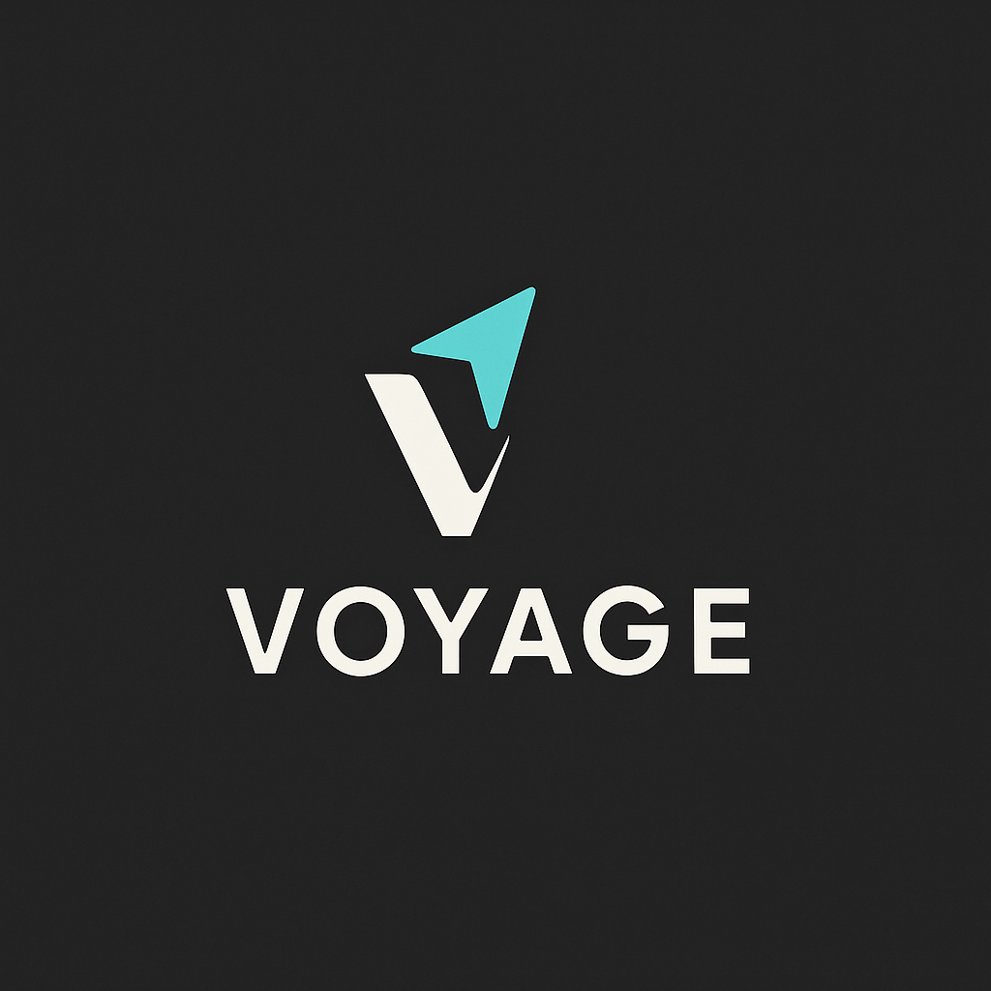

## Style Guide

### Color Palette

|  |  |  |  |  |
| --- | --- | --- | --- | --- |
| **Primary** | **Secondary** | **Accent 1** | **Accent 2** | **Text Color** |
| #1C1C1E | #E2C290 | #4FD1C5 | #63B3ED | #F5F5F5 |

### Typography

#### Heading Font: Poppins Bold

#### Paragraph Font: Inter Regular

### Navigation

Home Destinations 2 Plan 3

The nav bar will be on the left of the screen that appears when hovered over.

**Content**

Layout for the Home Page:

Header (hero):

* Site name and logo at the top center of the page
* Heading: Plan Less. Travel More.
* Image behind the heading and header paragraph:

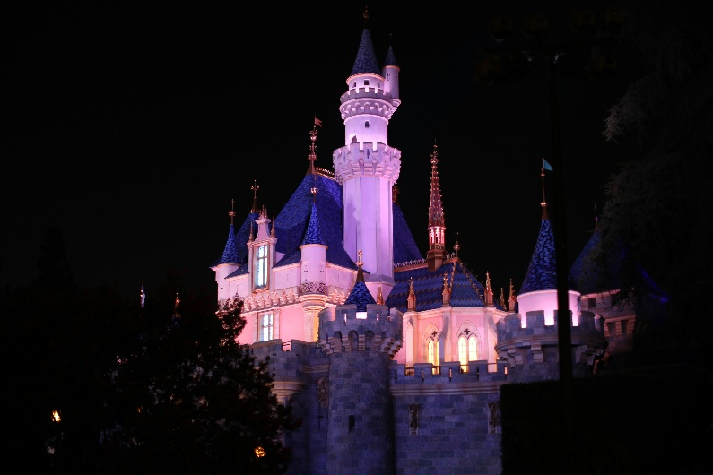

* Header Paragraph: Voyage is your travel companion designed to simplify how you discover destinations, calculate costs, and build your perfect trip itinerary with ease. Whether you’re daydreaming or diving into details, we’ve got every mile mapped.

Style:

* Background: (#1C1C1E)
* Image: 1920x1080, slightly blurred
* Font: poppins bold
* Text Color: (#F5F5F5)
* Centered Vertically and Horizontally

Feature Sections (2 panels below the hero):

Each of the sections includes:

* A full-width layout

One large image for each section

Subheading_1: Find Your Next Destination

Description_1: Browse curated vacation spots around the world with cost estimates, nearby stays, and must-see highlights—all tailored to your preferences.

Image behind the text:

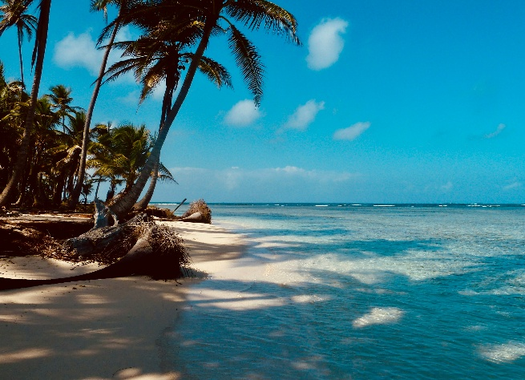

Subheading_2: Your Trip Your Way

Description_2: Choose where to stay, how to get there, and what to do. Our customizable planner helps you organize your itinerary and stay on budget—your travel schedule, all in one place.

Image behind the text:

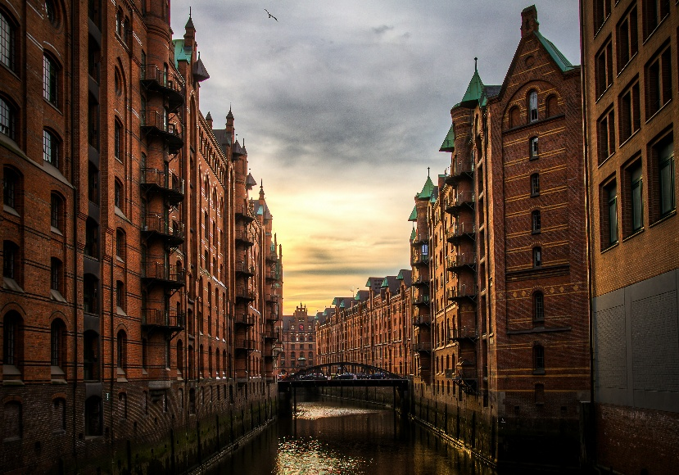

* Buttons:

Button_1: “Explore Destinations” links to /destination page

Button_2: “Start Planning” links to /plan page

* Styling:

Accent colors: #4FD1C5, #63B3ED, #E2C290 for buttons and highlights

Text: (#F5F5F5)

Button hover effect (slight glow or color shift)

**Footer:**

* Content:

Copyright: © 2025 Voyage

Quick Links: Home | Destinations | Plan

* Styling:

Background: #E2C290

Font Size: small, centered

Link color: #F5F5F5 with hover color #63B3ED

**Nav Bar (Left Side):**

* Behavior: hidden by default with a hamburger icon (three lines stacked on top of one another), appears on hover
* Position: fixed on the left side
* Contents:

Icons for:

Home



Destinations



Plan



* Styling:

Background: #2A2A2E

Link text: #F5F5F5

Icon Color: #F5F5F5

Icon Size: 20-24 px

Hover color: #4FD1C5 or #63B3ED

**1. Destinations Page**

**Page Elements**

**Header**

* Same layout and styling as homepage header
* Title: "Top 5 U.S. Destinations"
* banner image (blurred background)

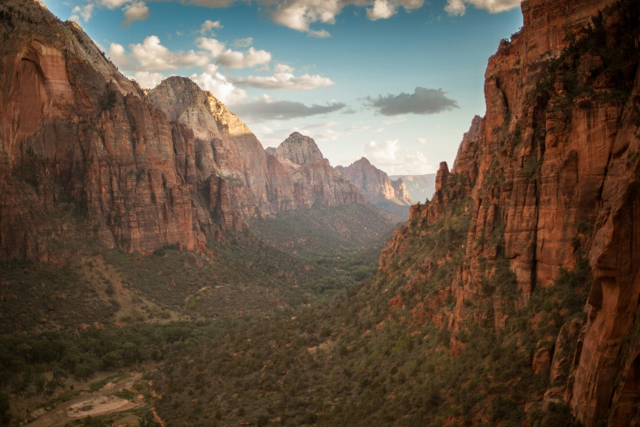

**Destinations Grid**

* 5 sections, one for each location
* Each includes:
  + **Location Name (h2, Poppins Bold)**
  + **Image** (800x500 placeholder)
  + **Short Description** (Inter Regular)

**Top 5 Locations to Feature**

1. **New York City, NY**
   * Image:

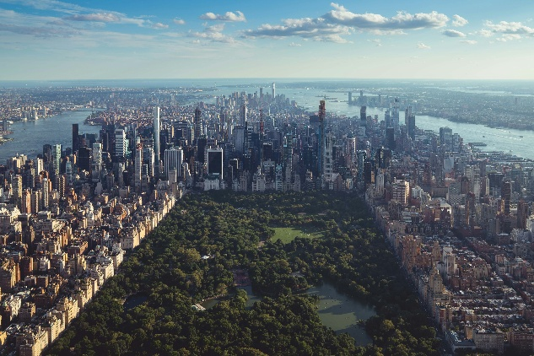

* + Description:
  + From Times Square to Central Park, NYC blends iconic landmarks, world-class dining, Broadway, and a vibrant culture that never sleeps.

1. **Orlando, FL**
   * Image:

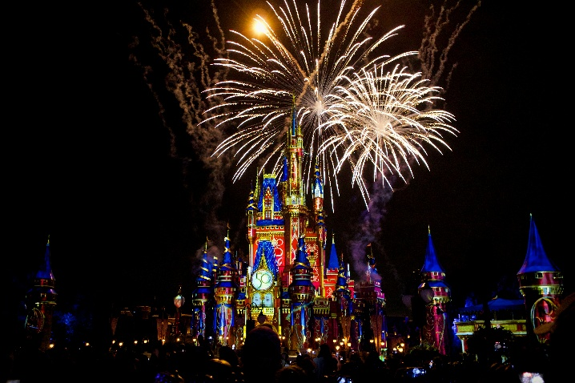

* + Description: A dream destination for families, Orlando offers theme park thrills, resort relaxation, and sun-soaked adventures year-round.

1. **Las Vegas, NV**
   * Image:

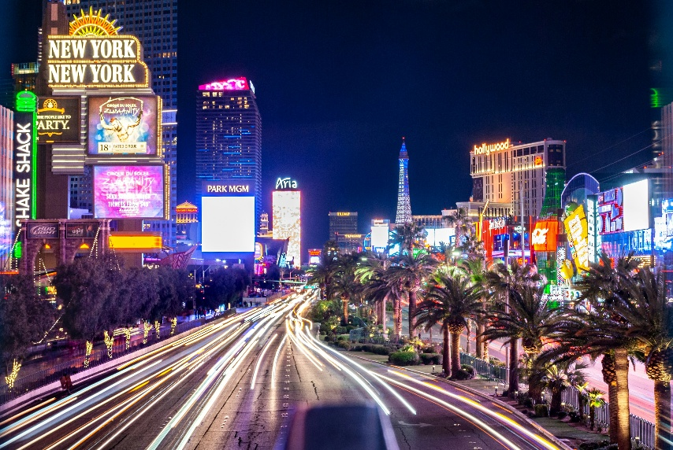

* + Description: Bright lights, entertainment, casinos, and fine dining make Vegas a top pick for excitement and unforgettable nightlife.

1. **Honolulu, HI**
   * Image:

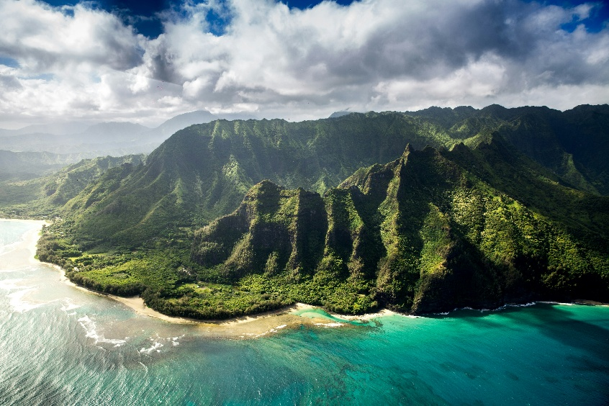

* + Description: Relax on white-sand beaches, hike volcanic trails, and immerse yourself in the natural beauty and culture of the Hawaiian Islands.

1. **Los Angeles, CA**
   * Image:

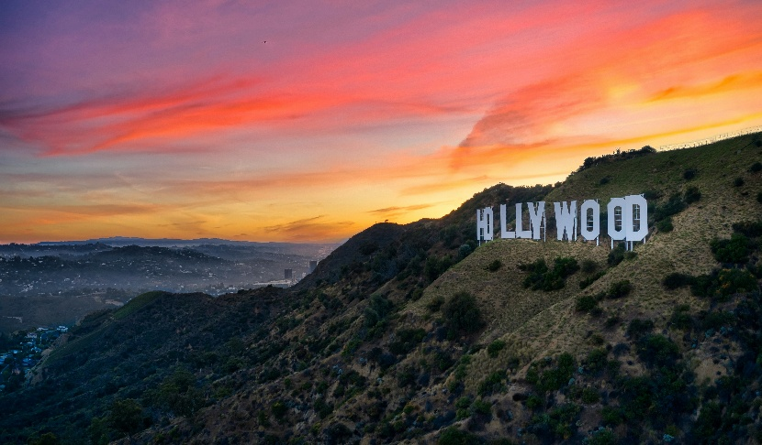

* + Description: A dynamic blend of beach, entertainment, and urban adventure—LA invites travelers to explore the glamour of Hollywood and beyond.

**Footer**

* Same as homepage (© 2025 Voyage | Home | Destinations | Plan)

**Sidebar Navigation**

* Home, Destinations (highlighted), Plan with icons and hover reveal

**2. Plan Page**

**Page Purpose**

To provide users with transparent, up-to-date cost estimates for travel, lodging, and ticketed experiences in each of the 5 featured destinations.

**Page Elements**

**Header**

* Same as homepage, with title: "Plan Your Trip"
* hero image (slightly blurred)



**Planning Table or Card Layout**

* One section for each destination
* Each includes:
  + **Location Name (h2)**
  + **Image** (same as Destinations page for consistency)
  + **Cost Breakdown Table** 
    - **Travel Estimate**: flight or fuel range (e.g., $200–$500 round trip)
    - **Lodging**: average nightly hotel or Airbnb cost (e.g., $150/night)
    - **Tickets**: cost range for main attractions (e.g., Disney tickets, show passes)

**Top 5 Locations Cost Format**

**Orlando, FL**

* Travel: $250–$400 round trip
* Lodging: $130–$180/night
* Tickets: $110–$150 per theme park/day

**New York City, NY**

* Travel: $200–$350 round trip
* Lodging: $200–$300/night
* Tickets: $50–$150 for Broadway shows and major attractions

**Las Vegas, NV**

* Travel: $180–$320 round trip
* Lodging: $100–$180/night
* Tickets: $80–$200 for shows, clubs, and attractions

**Honolulu, HI**

* Travel: $400–$700 round trip
* Lodging: $180–$300/night
* Tickets: $30–$100 for excursions and cultural sites

**Los Angeles, CA**

* Travel: $220–$370 round trip
* Lodging: $150–$250/night
* Tickets: $40–$120 for studio tours and theme parks

**Footer**

* Same as homepage (© 2025 Voyage | Home | Destinations | Plan)

**Sidebar Navigation**

* Home, Destinations, Plan (highlighted), hover-reveal with icons

**Styling Consistency**

* Colors: Use #1C1C1E background, #F5F5F5 text, #4FD1C5 / #63B3ED buttons
* Fonts: Poppins Bold for headings, Inter Regular for paragraphs
* Images: Consistent size and layout to match homepage features
* Buttons (optional): "Start Planning" or "More Info" for each section

**Wireframes**

### Home

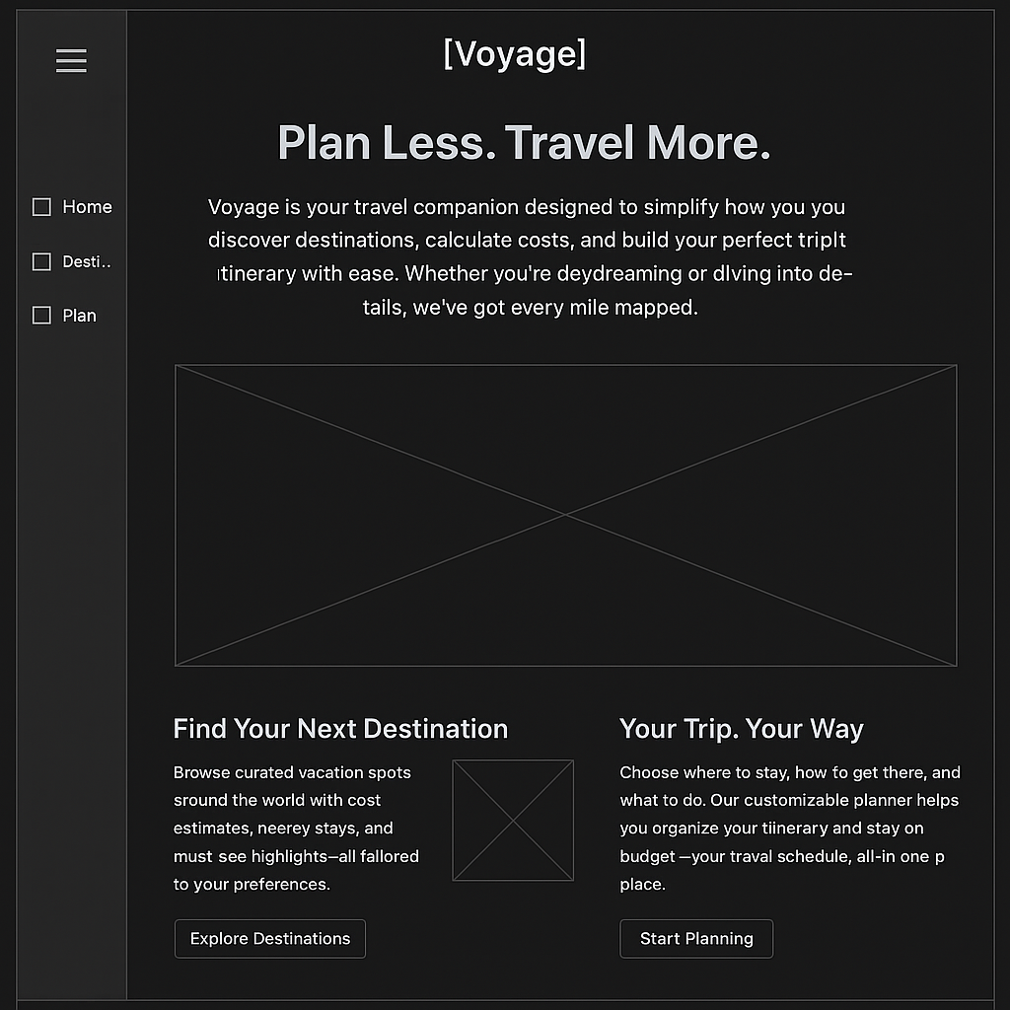



Destinations

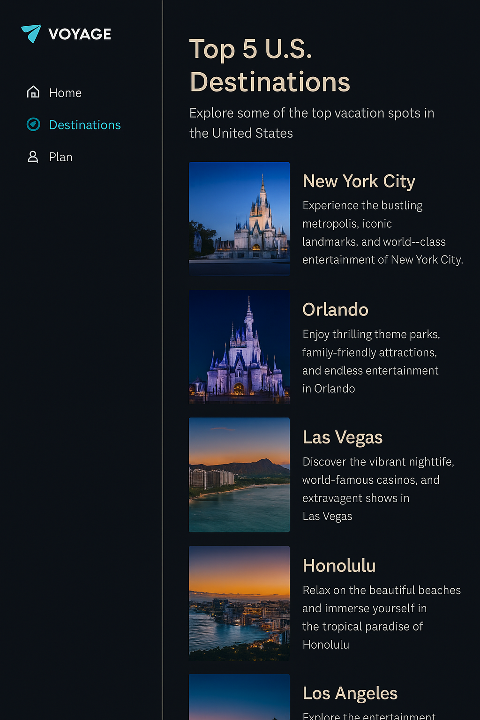



Plan

